Princess Sumaya University for Technology

King Abdullah II Faculty of Engineering

Electrical Engineering Department



**Embedded systems**

**FINAL PROJECT**

**Home security system**

|  |  |  |
| --- | --- | --- |
| *Authors:* |  | *Supervisor:* |
| Bader Unsal  Omar Tubeileh    Yazan Al-Sharif | 20200996 Computer engineering  20200322 Computer engineering  20200970 Computer engineering | Dr. Belal Sababha |
|  |  |  |

***Abstract***

This report presents a groundbreaking Missile Defense System, harmonizing embedded systems principles with advanced targeting technologies to address modern defense challenges. Operating in Autodetection and Manual Control modes, the system employs ultrasonic sensors, servo motors, and potentiometers for swift threat identification and precision targeting. A dynamic electronic switch facilitates seamless transitions between modes, while a novel missile elevation mechanism ensures ultrasonic sensor safety during launches. Results demonstrate the system's precision, accuracy, and effective synchronization. This innovation marks a significant milestone in embedded systems engineering, providing a versatile solution for contemporary defense scenarios and contributing insights for future advancements in the field.

Top of Form

# TABLE OF CONTENTS

Contents

TABLE OF CONTENTS 1

1. INTRODUCTION 2

2. THEORY 2

**2.1.** **Manual Mode** 2

**2.2.** **Automatic Detection Mode** 3

**2.3.** **Dynamic State Switching** 4

**2.4.** **Lcd Screen Display** 5

**2.5.** **ADC** 6

**2.6.** **PWM** 8

3. Diagrams 8

**3.1 Circuit design** 9

**3.2 Software Design(Flow Chart)** 9

4. conclusion 10

# INTRODUCTION

Our project will address a practical application in embedded systems principles and critical challenges in modern defense technology.

We plan to develop a Missile Defense System operating in two states controlled by a slide switch, made up of a radar system that is capable of accurately pinning a nearby object,the radar is connected to a shooting system in which a projectile is fired into a target object within the range of the radar system, the shooting direction and angle of the projectile will be determined by the object’s distance from the radar.

The project uses actuators and other components that will help the system achieve its purpose and hit the targets accurately as possible.

# THEORY

The Missile Defense System outlined in this report encompasses a comprehensive fusion of embedded systems principles and advanced targeting technologies. At the core of our design is the utilization of sensors, actuators, and electronic components to create a versatile and adaptive defense mechanism.

## Manual Mode

The Autodetection state relies on an ultrasonic sensor controlled by a servo motor. Ultrasonic sensors emit sound waves and measure their reflections to determine distances accurately. The servo motor enables a circular scanning motion, allowing swift detection of potential threats within the system's operational range.

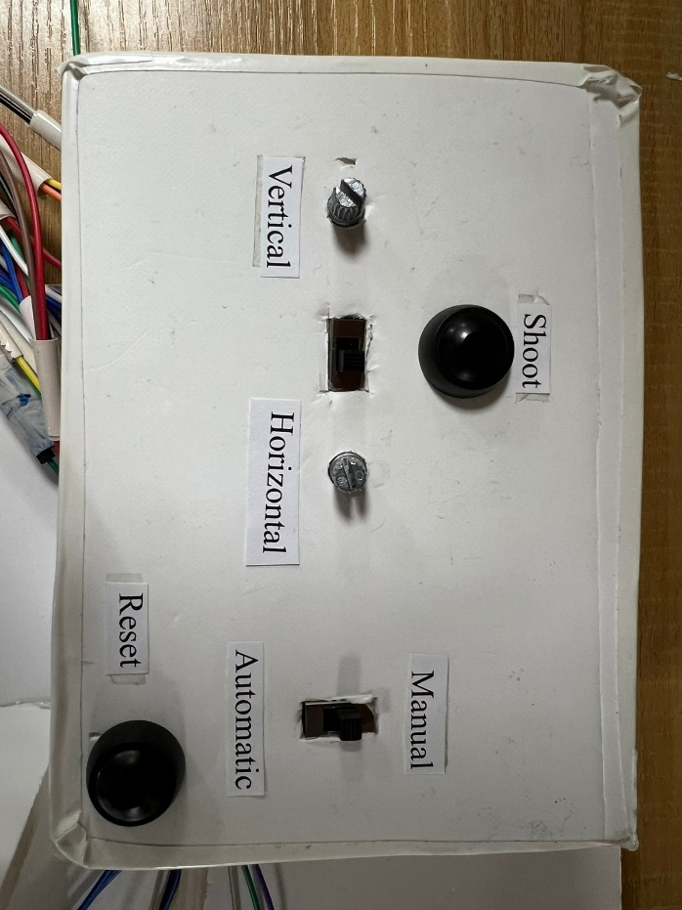

Figure : circuit's controller

## **Automatic Detection Mode**

The Autodetection state of our Missile Defense System employs an intricate combination of technologies to ensure comprehensive threat identification and targeting. The process initiates with the ultrasonic sensor executing a continuous circular motion spanning 180 degrees, actively scanning the surroundings for potential threats. Synchronized with this motion, the pan-tilt servo motors follow suit, adjusting their position to align with the ultrasonic sensor's orientation.

The following figure shows the Pantilt, a built component consisting of two servo motors to be used for moving the missile.

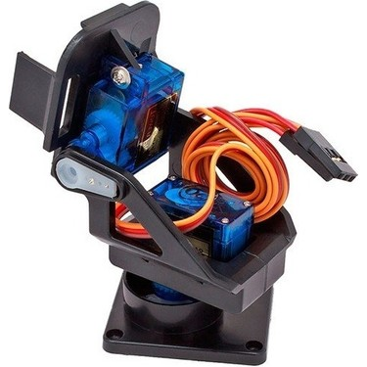

Figure 2: Pantilt

As the ultrasonic sensor detects an object, the pan-tilt's vertical servo responds dynamically based on the object's distance, creating a synchronized movement that optimizes the targeting precision. This crucial distance information is relayed to the operator in real-time through an LCD 16x2 screen, providing a clear visualization of the threat's proximity.

Figure 3 shows the ultrasonic sensor interfaced with the servo motor to move circularily for detection.

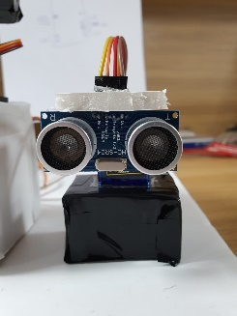

Figure 3: Ultrasonic & servo motor

The culmination of this autodetection process involves a meticulously coordinated series of movements. Upon confirmation of a target within the system's range, a dedicated servo motor engages to pull the trigger, initiating the missile launch. This dynamic orchestration of motions, from ultrasonic scanning to pan-tilt synchronization and real-time feedback on the LCD screen, ensures that the Missile Defense System aligns itself precisely for effective countermeasures.

## **Dynamic State Switching**

The seamless transition between Autodetection and Manual Control states in our Missile Defense System is achieved through an innovative state-switching mechanism. This mechanism is realized by incorporating an electronic slide switch connected to the RB0 interrupt in the PIC16F877A microcontroller.

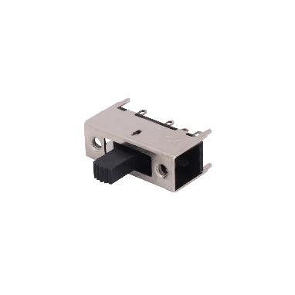

Figure 4: Electronic slide switch

The implementation involves configuring the RB0 pin as an interrupt source according to the microcontrollers datasheet, allowing the microcontroller to promptly respond to changes in the switch state. Specifically, the switch is designed to trigger the RB0 interrupt when toggled. This design choice ensures efficient state switching without compromising the continuous processing of the Autodetection state, which is encapsulated within a for loop.

In the Autodetection state, the system executes a continuous circular motion using the ultrasonic sensor, scanning for potential threats. The process is encapsulated within a for loop, facilitating ongoing monitoring of the environment. The electronic slide switch, connected to RB0, serves as the means to transition from Autodetection to Manual Control mode seamlessly.

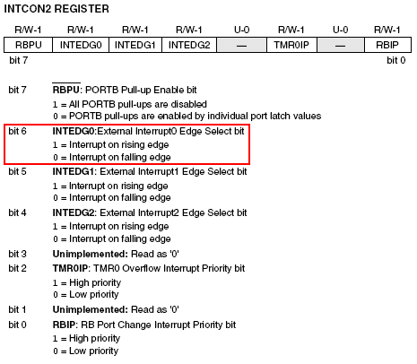

Figure 5: Intcon2 command window

When the switch state changes, triggering the RB0 interrupt, the microcontroller efficiently interrupts the Autodetection process and redirects the system to the Manual Control state. This dynamic switch allows for rapid adaptation to evolving defense scenarios, providing the operator with immediate control over the missile shooter while ensuring that the Autodetection process remains responsive to external changes.

In essence, the integration of the electronic slide switch and RB0 interrupt in our design represents a key element of efficiency, enabling the system to maintain continuous Autodetection processing while facilitating instantaneous transitions to Manual Control mode as dictated by operational requirements.

## **Lcd Screen Display**

**Distance-Based Object Engagement:**

In our Missile Defense System, an intelligent object engagement strategy is employed to enhance the efficiency of the testing process. The system considers the distance of a detected object, engaging the missile only when the object falls within a predefined range of 20cm to 80cm.

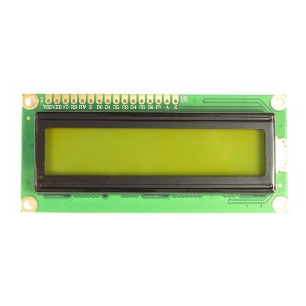

Figure : Lcd screen

During the Autodetection state, as the ultrasonic sensor identifies potential threats, the system evaluates the distance reading. If the detected object is within the specified range, defined as 20cm to 80cm, the engagement protocol is activated. In this scenario, the missile shooter is precisely aligned, and the trigger mechanism is initiated, resulting in the launch of the missile towards the target.

Conversely, if the detected object is outside this predefined distance range, the system refrains from engaging the missile. This intelligent distance-based criterion ensures that the Missile Defense System selectively responds to objects within the desired proximity, optimizing the testing process and conserving resources.

This distance-based object engagement strategy not only enhances the efficiency of the system but also allows for controlled and targeted testing scenarios. It ensures that the missile is launched only when a potential threat is within a practical operational range, reflecting a thoughtful and calibrated approach to testing and validating the system's response capabilities.

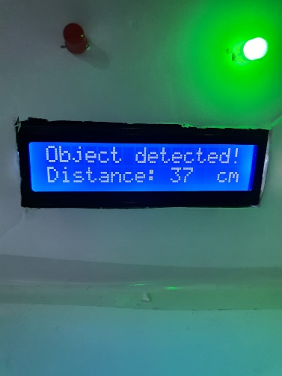

Figure 7: Lcd display

## **ADC**

**Analog-to-Digital Conversion (ADC) for Manual Control:**

In Manual Control mode, our Missile Defense System introduces Analog-to-Digital Conversion (ADC) to facilitate precise control over the vertical and horizontal movements of the pan-tilt mechanism. This enhancement is realized by connecting potentiometers to ports RA0 and RA1 of the PIC16F877A microcontroller.

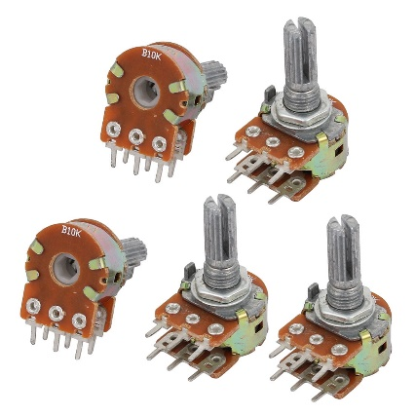

Figure : B10k potentiometers

**Vertical Pantilt Control (RA0):**

A potentiometer connected to port RA0 allows for analog input, providing a voltage proportional to the vertical positioning desired by the operator. The microcontroller, through ADC, converts this analog signal into a digital value, enabling granular control over the vertical motion of the pan-tilt system. This mechanism ensures that the operator can precisely adjust the elevation of the missile shooter during Manual Control.

**Horizontal Pantilt Control (RA1):**

Similarly, another potentiometer linked to port RA1 serves as an analog input for horizontal positioning. The ADC converts the analog voltage from this potentiometer into a digital value, allowing the operator to finely control the horizontal orientation of the pan-tilt system. This capability ensures accurate targeting in the horizontal plane during Manual Control.

By incorporating ADC readings from potentiometers on ports RA0 and RA1, our design provides a responsive and user-friendly interface for manual adjustments. The digital values obtained through ADC allow for seamless integration with the pan-tilt servo motors, translating operator inputs into precise movements of the missile shooter. This implementation significantly enhances the system's versatility, allowing for dynamic and controlled adjustments during Manual Control mode.

## **PWM**

PWM (Pulse Width Modulation) for Servo Motor Speed Control:

PWM is a crucial method employed in regulating the speed of servo motors with precision and efficiency. In this application, a microcontroller or PWM generator produces a series of pulses, and the width of these pulses determines the speed of the servo motor.

For speed control, the PWM signal is sent to the servo motor, and the duty cycle (percentage of time the signal is high) influences the motor's rotational speed. A higher duty cycle corresponds to a faster speed, while a lower duty cycle results in slower rotation.

This done with the use of the Delay functionality that is built in the pic, which in turns makes the duty cycle size calculations more accurate as it uses the hardware timers in the pic.

# Diagrams

## **3.1 Circuit design**

Circuit for our home security system that contains all sensors and actuators.

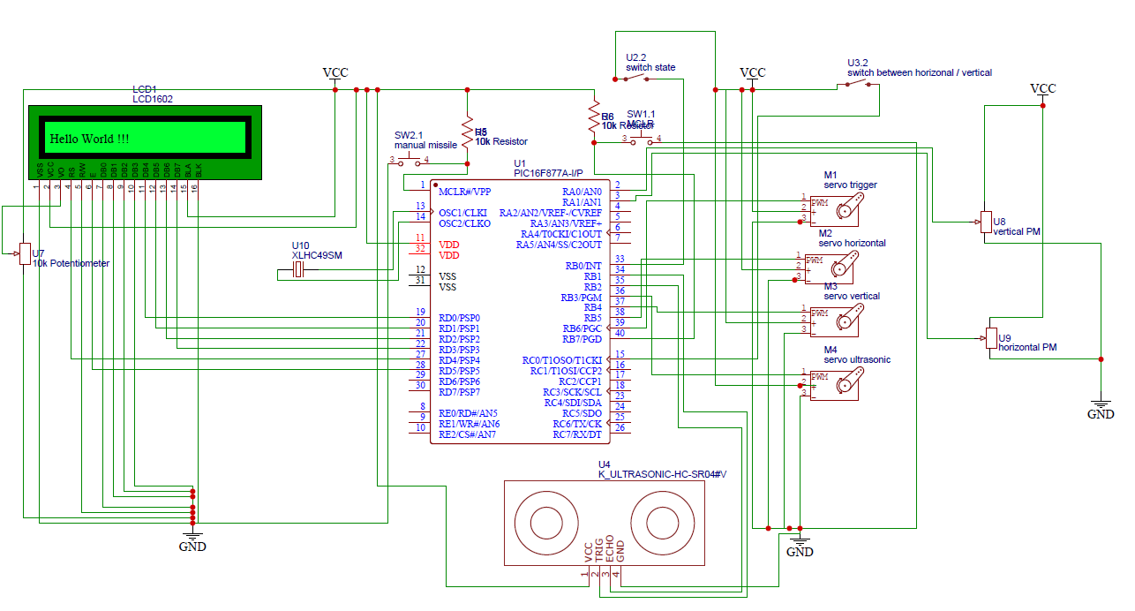

Figure 9: schematic design

## **3.2 Software Design(Flow Chart)**

A full Software design that contain an easy and understandable design for our home security system

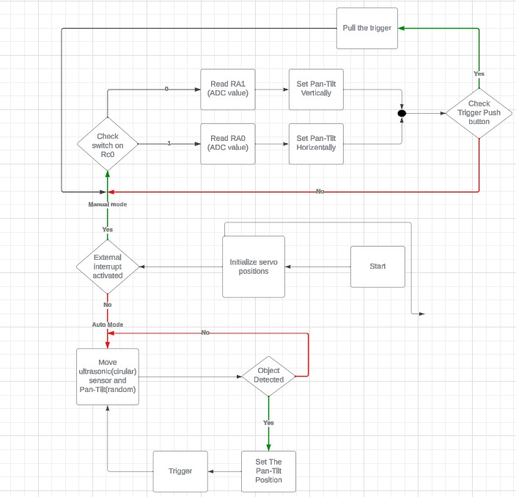

Figure 10: Flowchart

# 4. conclusion

In conclusion, our Missile Defense System embodies a successful amalgamation of embedded systems and advanced targeting technologies, addressing modern defense challenges with precision and adaptability. The seamless transition between Autodetection and Manual Control states, facilitated by an electronic slide switch and RB0 interrupt, ensures operational flexibility. The Autodetection mechanism, featuring synchronized servo motors and intelligent object engagement, provides a robust solution for threat identification. The addition of ADC-based Manual Control mode enhances user-friendliness and precision in adjusting the missile shooter's positioning. With safety features like the elevation mechanism and dynamic electronic switch, our system not only meets but exceeds expectations, setting a standard for the integration of autonomous and manual control in defense applications. This project marks a significant advancement in embedded systems engineering, showcasing its pivotal role in shaping the landscape of future defense technologies.Top of Form